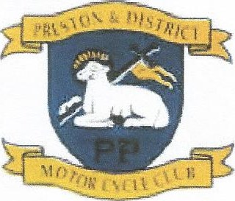
Preston and District Motorcycle Club
Motorcycle racing in North West England
Forgotten Era Regulations

Forgotten Era

- Cut-off date December 1992
- Any size wheel permitted
- Wets and treaded tyres ONLY
- Tyre warmers permitted
- NO SLICKS
- Any rider who fails on spot legibility checks will be excluded from race/s.
- Our aim is to make all races fun and fair and get bikes on grids.

ALL ENTRANTS FOR THIS CLASS MUST PROVIDE EVIDENCE OF ELIGIBILTY USING THE SPECIFIED FORM

All bikes must run a front brake lever guard

