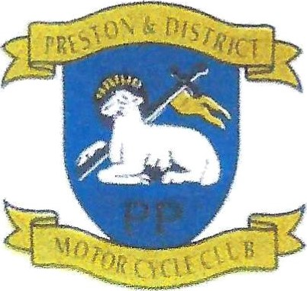
Preston & District Motor Cycle Club

Eligibility Form

Forgotten Era
All entrants to PDMCC Forgotten Era Championship MUST register their machine by completing this form. If any machine details change the machine must be re- registered by completing another form. This is to comply with the standard race regulations. The cut-off date for the class is manufactured before 31st December 1992.
Name:Race Number:(Leave blank if unknown)

Machine Details
Make: -

Model: -

Year of Production/Registration:
(It may be necessary to provide proof of machine age/year. IE. V5 document etc.)
Frame Number: -

Engine Number: Declaration
By signing below, I declare that the above details are correct. I understand Technical Officials may verify any of the above details at any time and any discrepancies may result in being withdrawn from the championship.
Signed: Date:

For club use only:
Checked *Yes/No
Eligibility Officer Signature Date ________________________
Comments:

